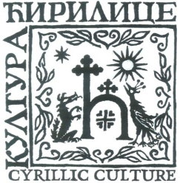
Удружење грађана
КУЛТУРА ЋИРИЛИЦЕ
Београд, моб: +381 63 28 36 28
е-адреса: kulturacirilice@gmail.com Текући рачун 205-160312-78
Citizens Association
CYRILLIC CULTURE

Belgrade, mobile: +381 63 28 36 28
е-mail: kulturacirilice@gmail.com
ПИБ 106451332

INTERNATIONAL CALLIGRAPHY EXHIBITION
Organized by "Kultura cirilice"
At the Applied Arts Museum, Belgrade

We are inviting calligraphers (Members of Arts Associations as well as freelance typographic alphabet artists) to take part in this Exhibition.

The Exhibition will be staged at the Museum of Applied Arts in Belgrade in June 2018.
All calligraphy works should represent their respective national language and alphabet.
The exhibiting terms are as follows:
- One artist may send three (3) works maximum;
- All entries should be sent in a PDF form and in 300 dpi resolution and of 50×70cm format;
- Artists should enclose a photo and CV to the following email address:
kulturacirilice@gmail.com
- The submission deadline: 10 May, 2018.

After Belgrade, the Exhibition will be organized as a traveling event and as such will be staged in different countries in the world.
All works will be handled with utmost care but the Organizer shall not be responsible for possible loss and/or damage during transport and display of works.
The Organizer may exercise their right to freely use any and all accepted works for promotional publicity and relevant events without any payment obligation.
It is implicit that authors taking part in the Exhibition accept the above mentioned terms and that the Authors shall remain in control of their copyrights and all partaking issues concerning the relevant works.
Please note that the Civic Association "Kultura Ćirilice" is a non-profit organization and that all our activities, including this Exhibition, are thus non ofit, too.

In Belgrade, 29 January, 2018

